# Bit manipulation

bitSet(Byte,bit) changes a specific bit inside a byte to 1.

bitClear(byte,bit) changes a specific bit inside a byte to 0.

# Two groups of interrupts

…

# PCMSK0 - Pin Change Mask Register 0

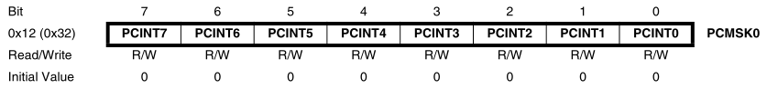

**Bits 7:0 – PCINT7:0: Pin Change Enable Mask 7:0**

Each PCINT7:0 bit selects whether pin change interrupt is enabled on the corresponding I/O pin. If PCINT7:0 is set and the PCIE0 bit in GIMSK is set, pin change interrupt is enabled on the corresponding I/O pin. If PCINT7:0 is cleared, pin change interrupt on the corresponding I/O pin is disabled.

# GIMSK – General Interrupt Mask Register

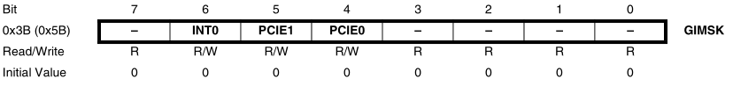

**Bit 4 – PCIE0: Pin Change Interrupt Enable 0**

When the PCIE0 bit is set (one) and the I-bit in the Status Register (SREG) is set (one), pin change interrupt 0 is enabled. Any change on any enabled PCINT7:0 pin will cause an interrupt. The corresponding interrupt of Pin Change Interrupt Request is executed from the PCI0 Interrupt Vector. PCINT7:0 pins are enabled individually by the PCMSK0 Register.

# GIFR – General Interrupt Flag Register

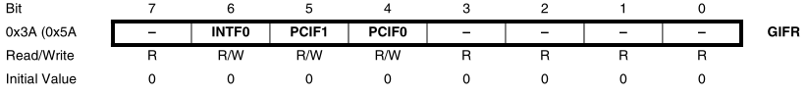

**Bit 4 – PCIF0: Pin Change Interrupt Flag 0**

When a logic change on any PCINT7:0 pin triggers an interrupt request, PCIF becomes set (one). If the I-bit in SREG and the PCIE0 bit in GIMSK are set (one), the MCU will jump to the corresponding Interrupt Vector. The flag is cleared when the interrupt routine is executed. Alternatively, the flag can be cleared by writing a logical one to it.

# SREG – AVR Status Register

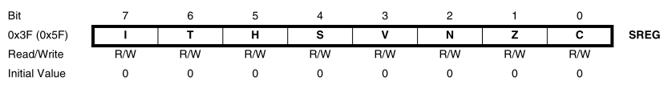

**Bit 7 – I: Global Interrupt Enable**

Must be set for the interrupts to be enabled. The individual interrupt enable control is then performed in separate control registers. If the Global Interrupt Enable Register is cleared, none of the interrupts are enabled independent of the individual interrupt enable settings. The I-bit is cleared by hardware after an interrupt has occurred, and is set by the RETI instruction to enable subsequent interrupts. The I-bit can also be set and cleared by the application with the SEI and CLI instructions, as described in the instruction set reference.

# MCUCR – MCU Control Register

The External Interrupt Control Register A contains control bits for interrupt sense control.

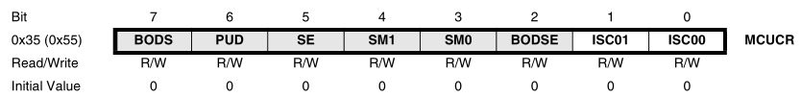

**Bits 1:0 – ISC01, ISC00: Interrupt Sense Control 0 Bit 1 and Bit 0**

The External Interrupt 0 is activated by the external pin INT0 if the SREG I-flag and the corresponding interrupt mask are set. The level and edges on the external INT0 pin that activate the interrupt are defined in Table 9-2. The value on the INT0 pin is sampled before detecting edges. If edge or toggle interrupt is selected, pulses that last longer than one clock period will generate an interrupt. Shorter pulses are not guaranteed to generate an interrupt. If low level interrupt is selected, the low level must be held until the completion of the currently executing instruction to generate an interrupt.

